**CSA1313- THEORY OF COMPUTATION**

M.Akhil

192210015

1. Design PDA using simulator to accept the input string anbn

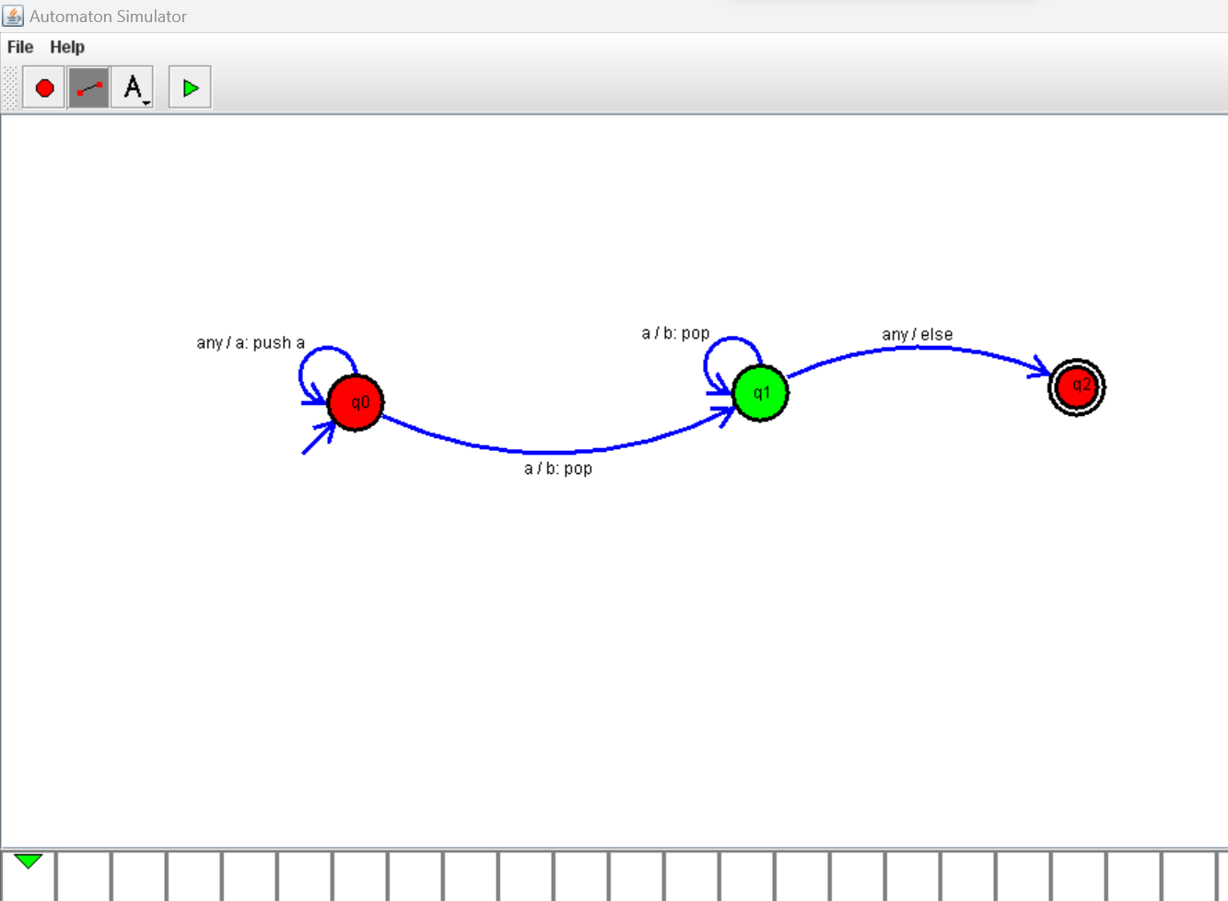

1. Design PDA using simulator to accept the input string anb2n

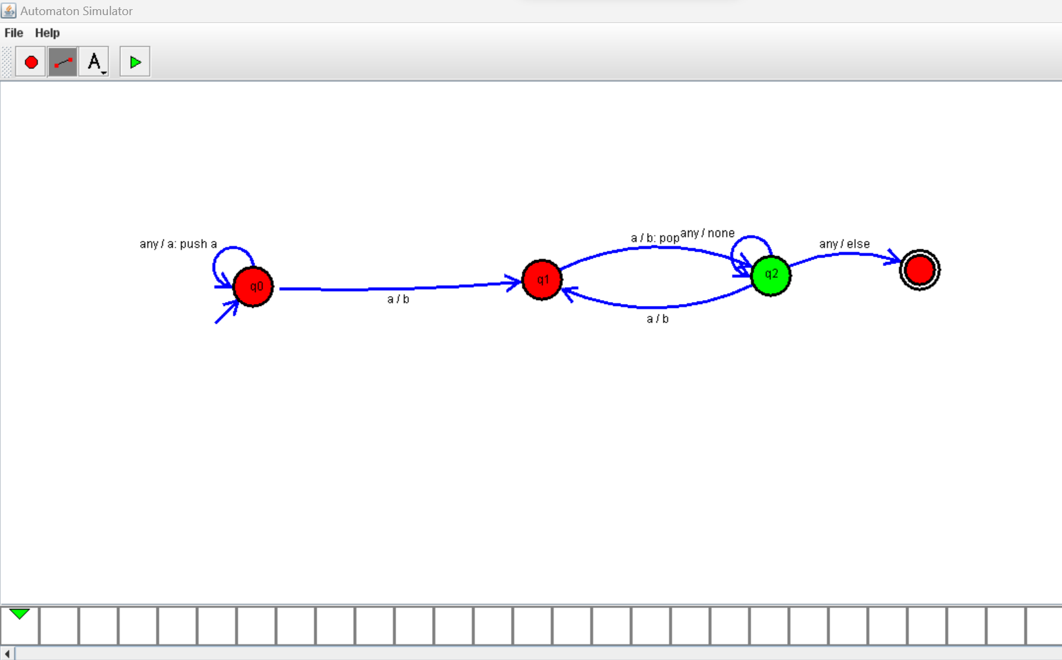

1. Design PDA using simulator to accept the input string aabb

